# Using .melt() to reshape government data - Corrected

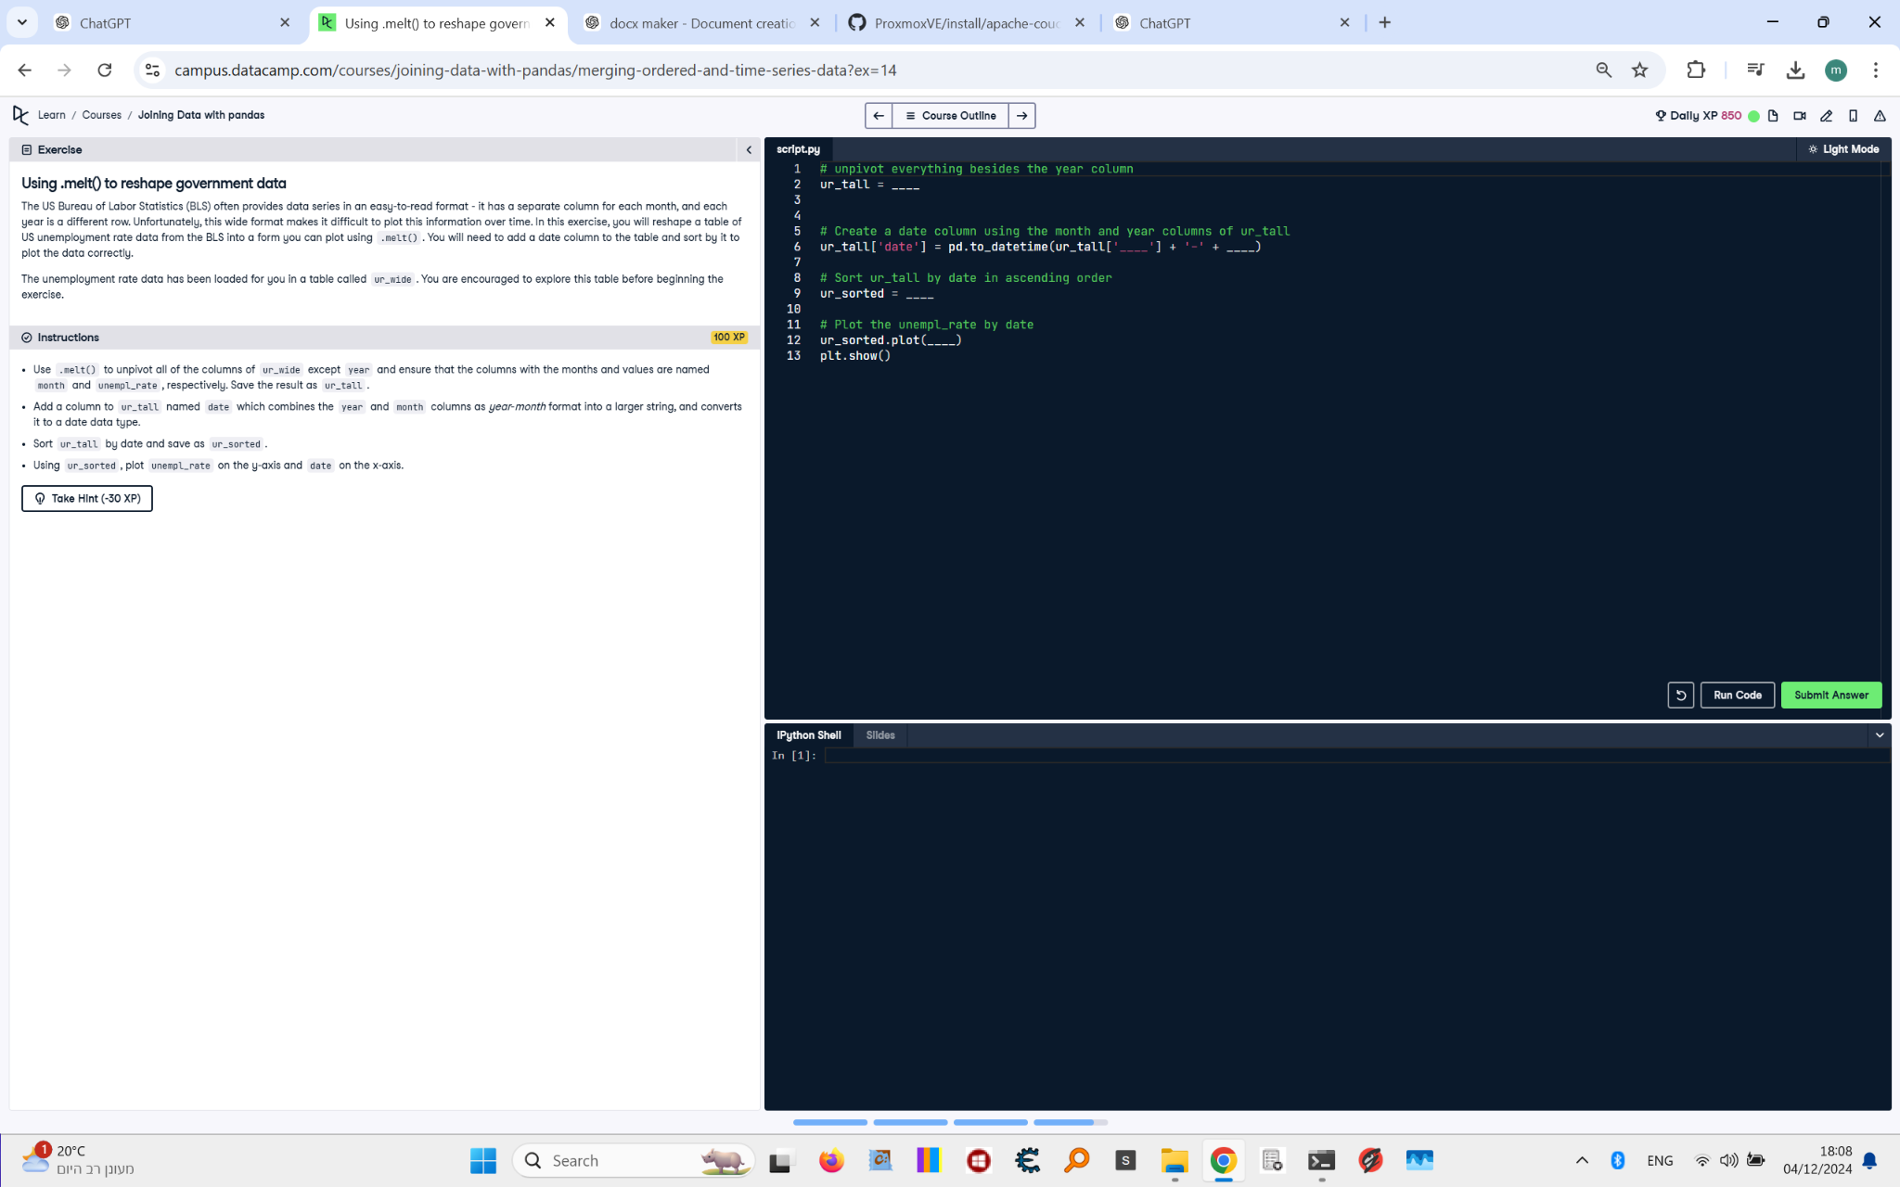

## Question:

The US Bureau of Labor Statistics (BLS) often provides data series in an easy-to-read format. In this exercise, you will reshape a table of US unemployment rate data from the BLS into a format you can plot using .melt(). You will need to:  
1. Unpivot all of the columns of ur_wide except 'year'. Ensure that the columns with the months and values are named 'month' and 'unempl_rate', respectively. Save the result as ur_tall.  
2. Add a column to ur_tall named 'date', which combines the 'month' and 'year' columns into a datetime format.  
3. Sort ur_tall by date and save as ur_sorted.  
4. Plot 'unempl_rate' on the y-axis and 'date' on the x-axis.

## Answer:

# Unpivot everything besides the year column  
ur_tall = ur_wide.melt(  
 id_vars=['year'],  
 var_name='month',  
 value_name='unempl_rate'  
)  
  
# Create a date column using the month and year columns of ur_tall  
ur_tall['date'] = pd.to_datetime(  
 ur_tall['month'] + '-' + ur_tall['year']  
)  
  
# Sort ur_tall by date in ascending order  
ur_sorted = ur_tall.sort_values('date')  
  
# Plot the unempl_rate by date  
ur_sorted.plot(  
 x='date',  
 y='unempl_rate'  
)  
plt.show()